AI-Generated / Template Resume Detection (Emerging & Hot Topic)
4

🔍 Idea
Detect resumes written using AI tools or templates.

🧠 Novelty
Highly relevant after ChatGPT adoption.

🧪 Research Tasks
- Stylometric analysis
- Semantic similarity clustering
- Perplexity-based detection
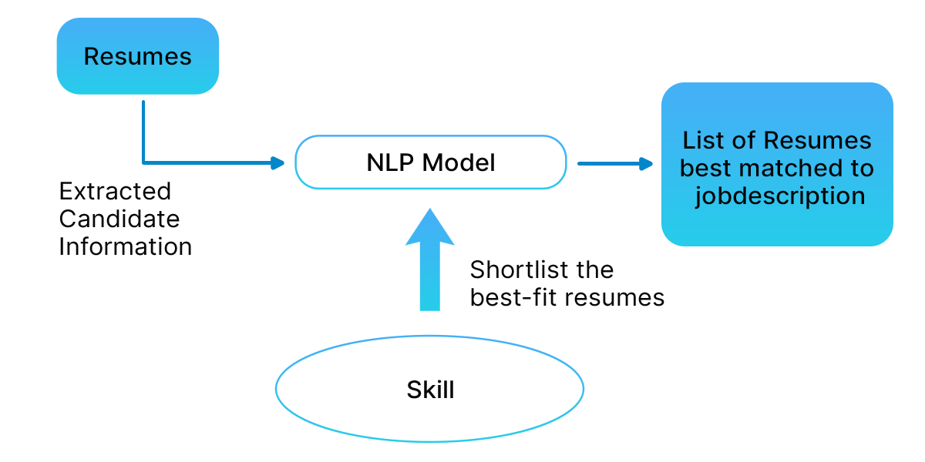
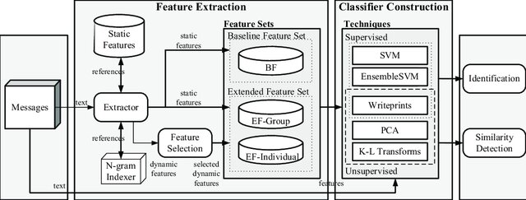
The increasing use of AI text generation tools and resume templates has led to a surge in synthetic or semi-synthetic resumes, making it difficult for recruiters to assess candidate authenticity.
Traditional Applicant Tracking Systems (ATS) focus on keyword matching, failing to identify stylometric uniformity, template reuse, and AI-generated linguistic patterns.
This research aims to design an automated, explainable, and weakly supervised system to detect AI-generated or template-based resumes without requiring fully labeled fraud datasets.

2️⃣Research Objectives

Detect AI-generated resumes using stylometric and semantic signals

Identify template-based resumes via similarity and structure analysis

Address lack of labeled data using weak supervision

Provide explainable outputs for HR decision support

3️⃣ Research Questions (Strong for Publications)

How do AI-generated resumes differ linguistically from human-written resumes?

Can stylometric + semantic features reliably identify synthetic resumes?

How effective are weak labeling strategies compared to fully supervised learning?

Can explanation mechanisms improve HR trust and usability?

4️⃣ Dataset Strategy (Critical Section)
🔹 4.1 Real Human-Written Resumes

Sources:

Kaggle resume datasets (PDF / text)

Public resume samples from career portals

Alumni-shared anonymized resumes

Label: Assumed human-written (noisy but realistic)

🔹 4.2 AI-Generated Resume Dataset (Synthetic Creation)

Generate resumes using:

Prompt-based generation (skills, experience, roles)

Multiple AI tools

Different verbosity and tone styles

Variations:

Fresh graduates

Mid-level professionals

Career switchers

Label: AI-generated (high confidence)

🔹 4.3 Template-Based Resume Dataset

Sources:

Free resume templates (Word / Overleaf / Canva)

Resume builders

Process:

Fill templates with diverse content

Preserve formatting structure

Vary wording slightly

Label: Template-generated

🔹 4.4 Mixed / Hybrid Resumes (Hard Cases)

Human resumes edited using AI

Template resumes manually paraphrased

Label: Uncertain / weakly labeled

5️⃣ Weak Labeling Strategies (Core Novelty)
🧠 5.1 Heuristic-Based Weak Labels
Heuristic Signal
High sentence uniformity AI-generated
Repetitive skill phrasing Template-based
Low lexical diversity AI-generated
Structural similarity Template reuse
🧠 5.2 Similarity-Based Labeling

Sentence embedding similarity clustering

Near-duplicate detection

Resume-to-resume cosine similarity

Clusters with high similarity → Template candidates

🧠 5.3 Stylometric Labeling

Features:

Average sentence length

POS tag distribution

Function word frequency

Readability scores

Outliers → Synthetic likelihood

🧠 5.4 Confidence-Weighted Labels

Each resume gets:

Label + confidence score
Used in noise-robust training

6️⃣ Methodology
🔹 6.1 Feature Engineering

Stylometric Features

Lexical richness

Burstiness & perplexity

Repetition metrics

Semantic Features

Sentence embeddings

Topic coherence

Structural Features

Section ordering

Bullet density

Formatting consistency

🔹 6.2 Model Architectures
Model Purpose
Classical ML (RF, XGBoost) Baseline
Transformer-based classifier Semantic modeling
Hybrid stylometric + semantic model Final system
🔹 6.3 Weakly Supervised Training

Train with noisy labels

Loss weighting by confidence

Iterative self-training

7️⃣ Explainability Layer (HR-Critical)

Explain predictions using:

Feature attribution

Highlighted suspicious sections

Template similarity explanations

Example Output:

Flagged due to high sentence uniformity and similarity to known templates.

8️⃣ Evaluation Strategy
🔹 Metrics

Precision, Recall, F1-score

AUROC

False Positive Rate (HR-sensitive)

🔹 Robustness Tests

Human vs AI paraphrased resumes

Cross-template generalization

Proposed model
• Resume document ingestion (PDF / DOCX / TXT)
• Text extraction and normalization
• Resume section segmentation
• Sentence and bullet point extraction
• Stylometric feature extraction
• Semantic embedding generation
• Structural and layout feature extraction
• Weak label assignment with confidence scores
• Similarity-based clustering for template detection
• Multi-view feature fusion
• Confidence-weighted weakly supervised training
• Iterative self-training with pseudo-label refinement
• Multi-class resume authenticity classification
• Resume-level fraud confidence scoring
• Explainable output generation
• Final decision and report generation

